2020

DAY 1 ASSIGNMENT

Nayeemuddin Sheriff

|  |  |
| --- | --- |
| HTTP v1.1 | HTTP v2 |
| Developed by Timothy Berners-Lee in 1989 as a communication standard for the World Wide Web | Developed primarily at Google with the intention of reducing web page load latency |
| It will process one request at a time. | It will process multiple request at a time. |
| Acknowledgement is necessary in order to process second request. | Acknowledgement is not necessary, as it can send multiple request and can receive multiple acknowledgement. |
| It uses HTTP as protocol. | It uses SPDY Protocol. |
| It uses text-based commands to complete HTTP requests. | It uses binary commands (1s and 0s) to complete HTTP requests. |
| Processing speed for a request is slow | It loads the web content 14.03% faster. |

# HTTP v1.1 vs HTTP v2

# CURL Sample

1. HTTP GET request

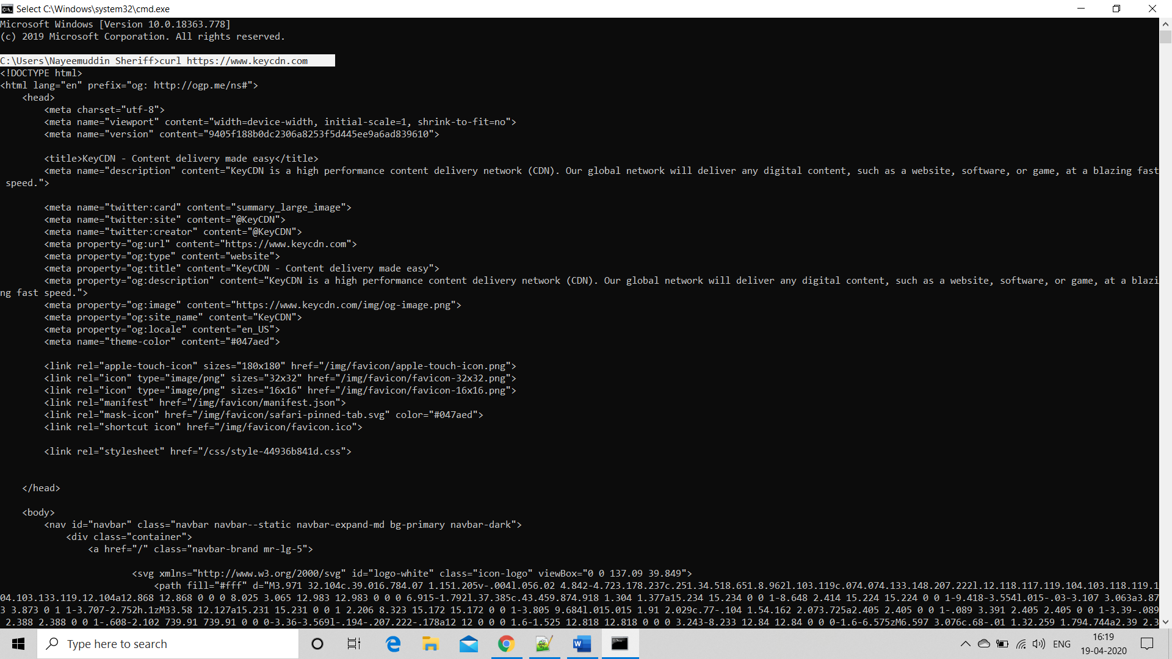

1. Returning only the HTTP headers of a URL

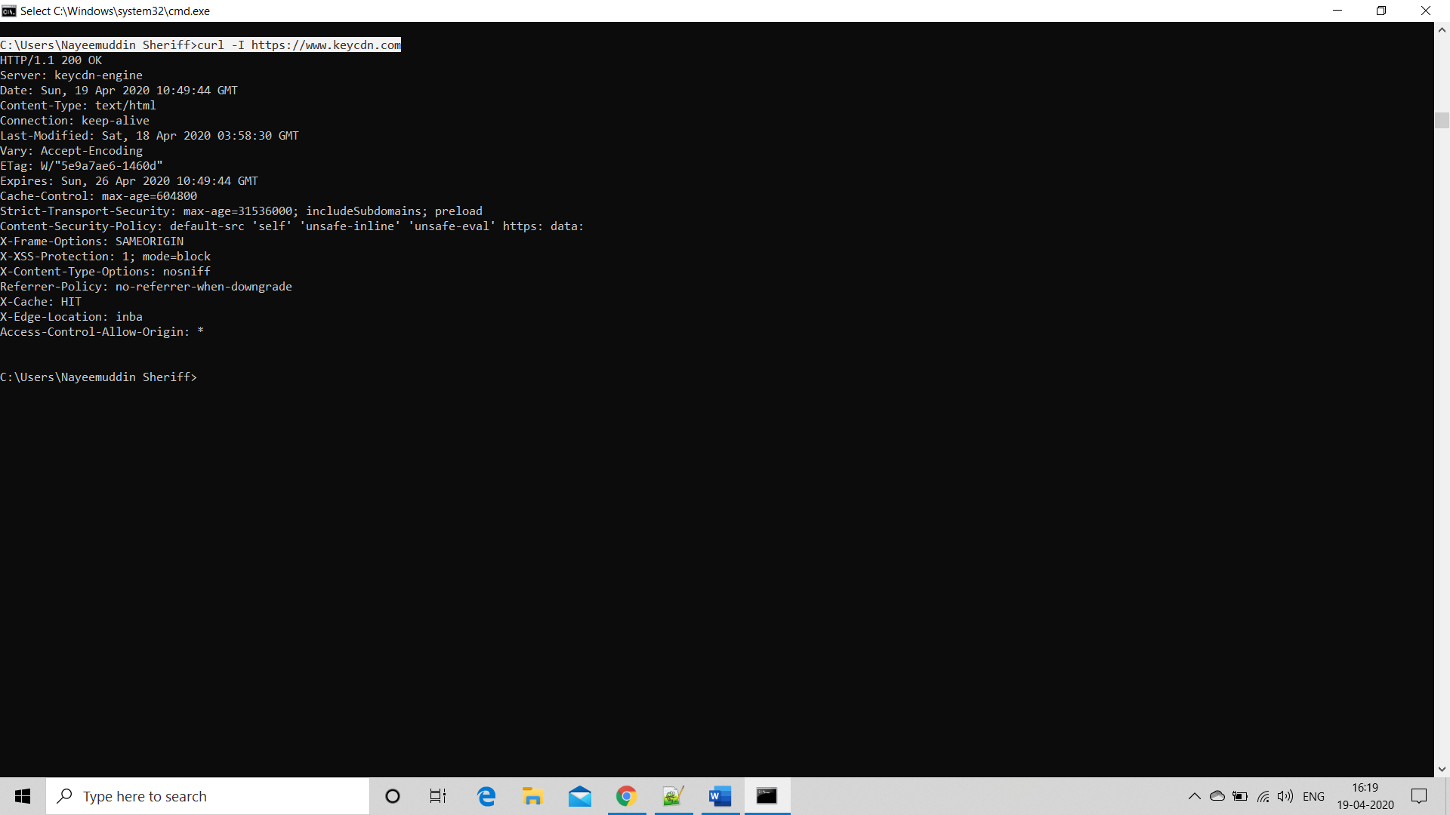

1. Saving the result of a curl command

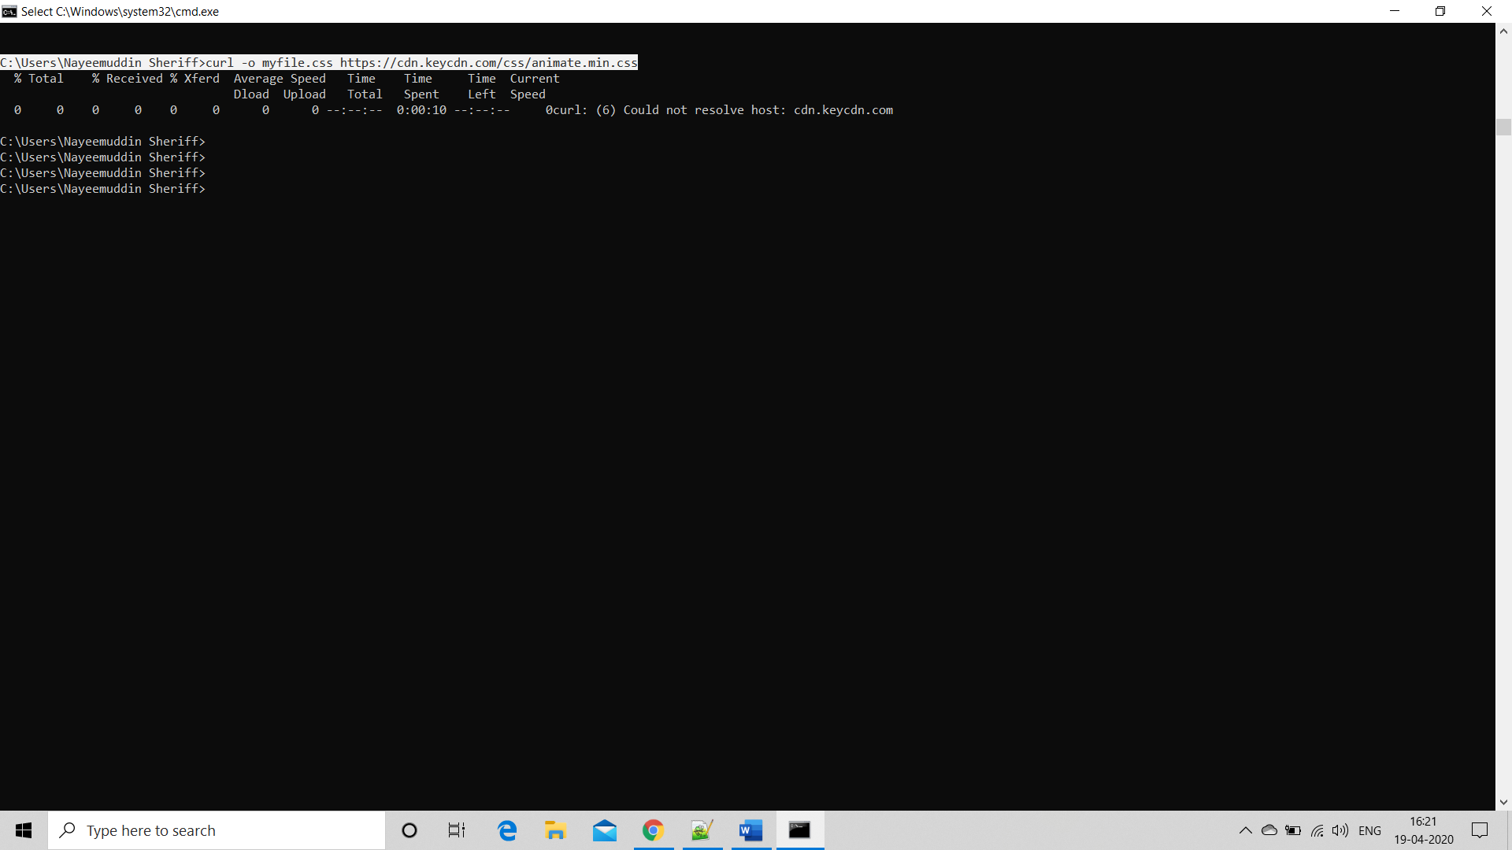

1. Adding an additional HTTP request header

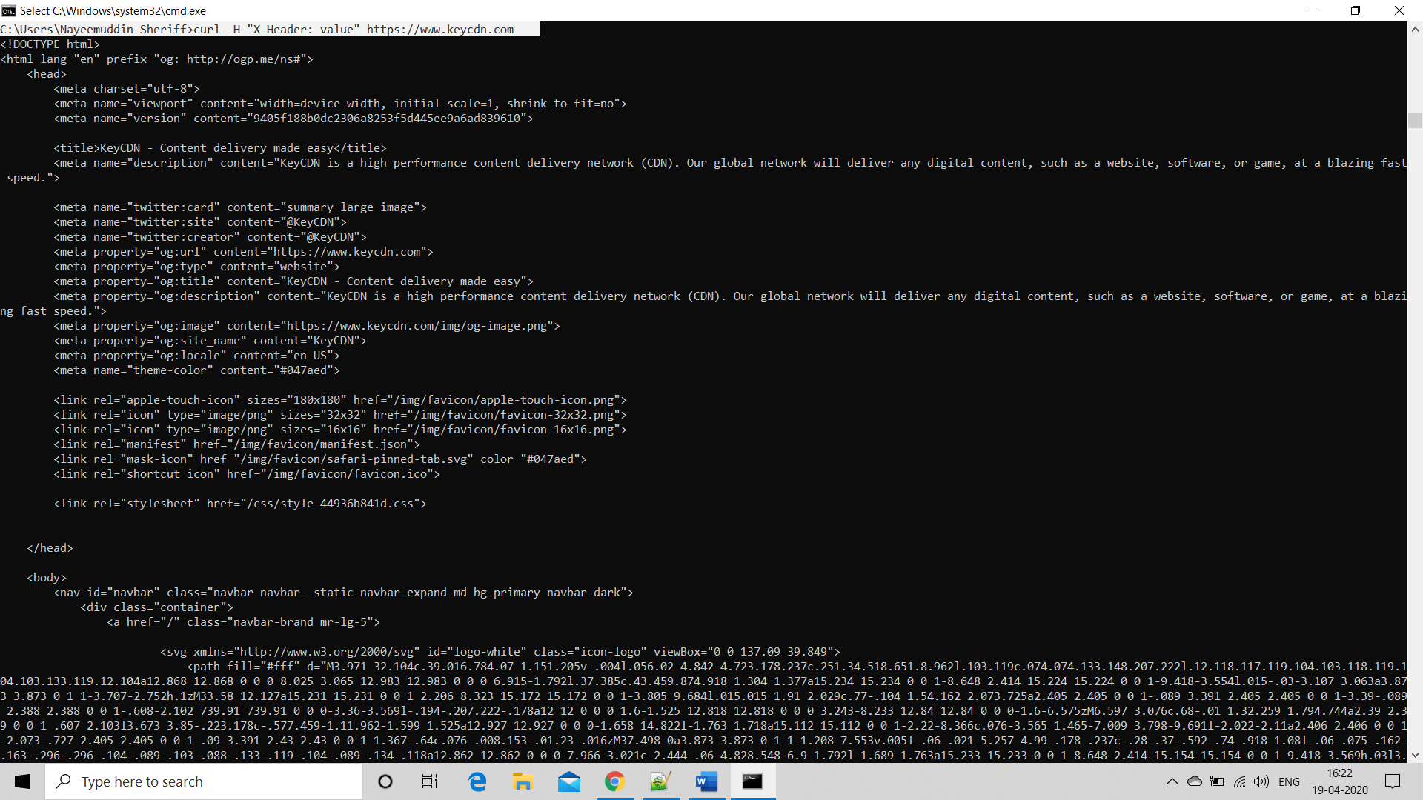

1. Generating additional information

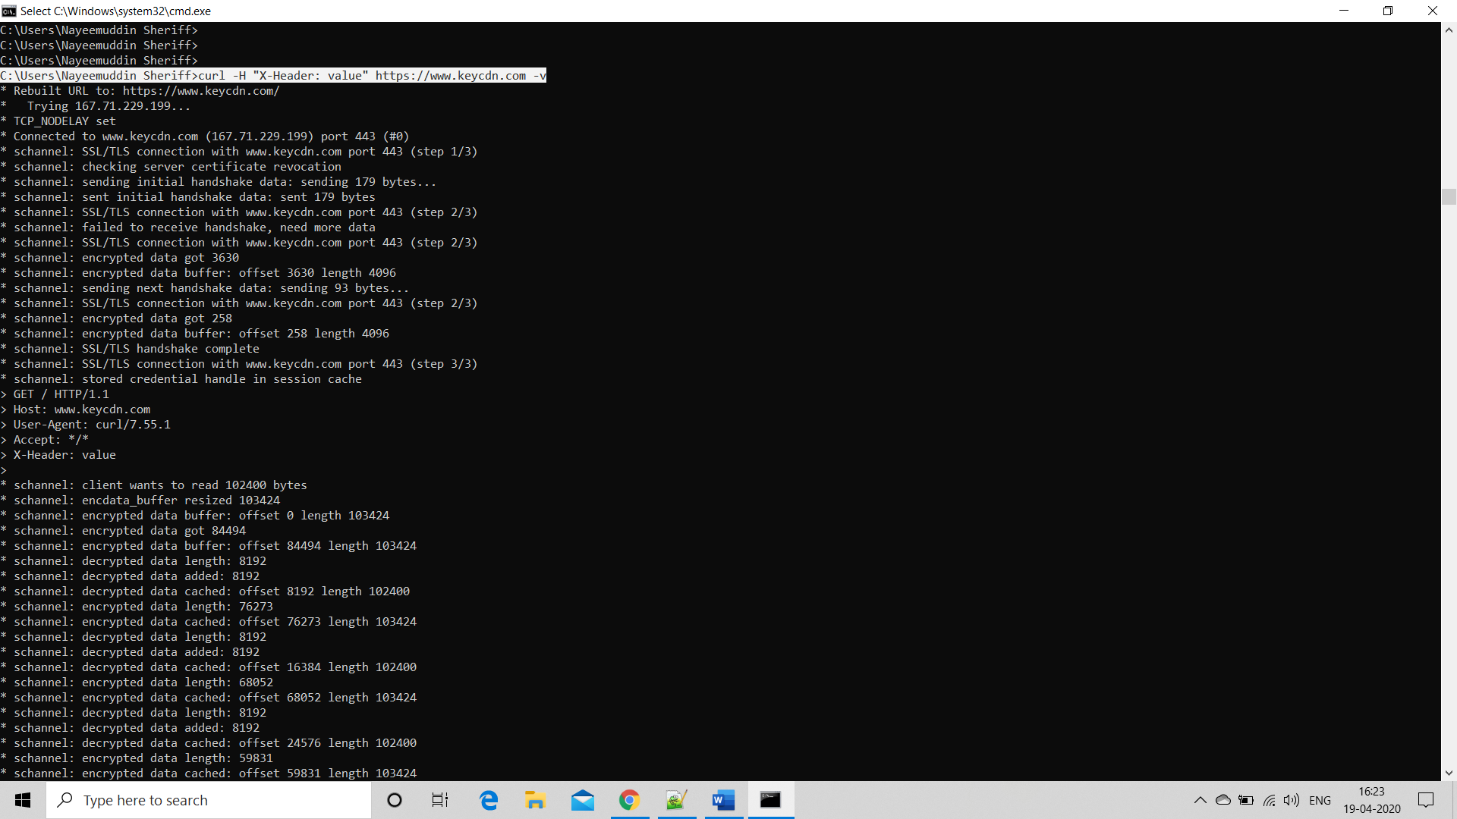

1. Resuming a download

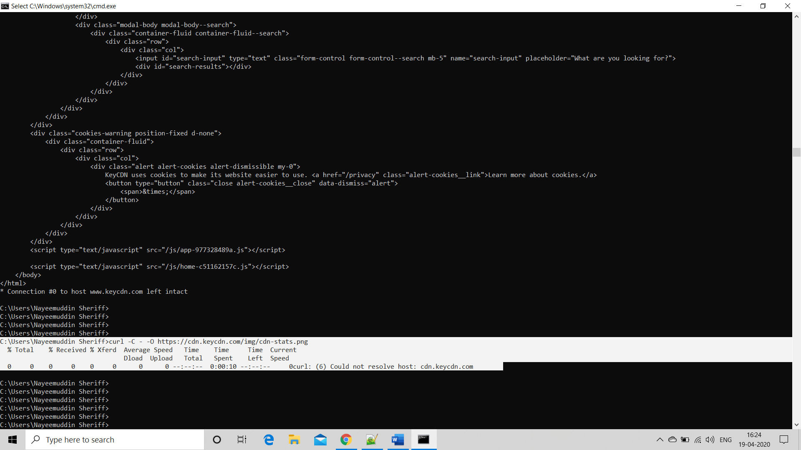

1. Storing HTTP headers

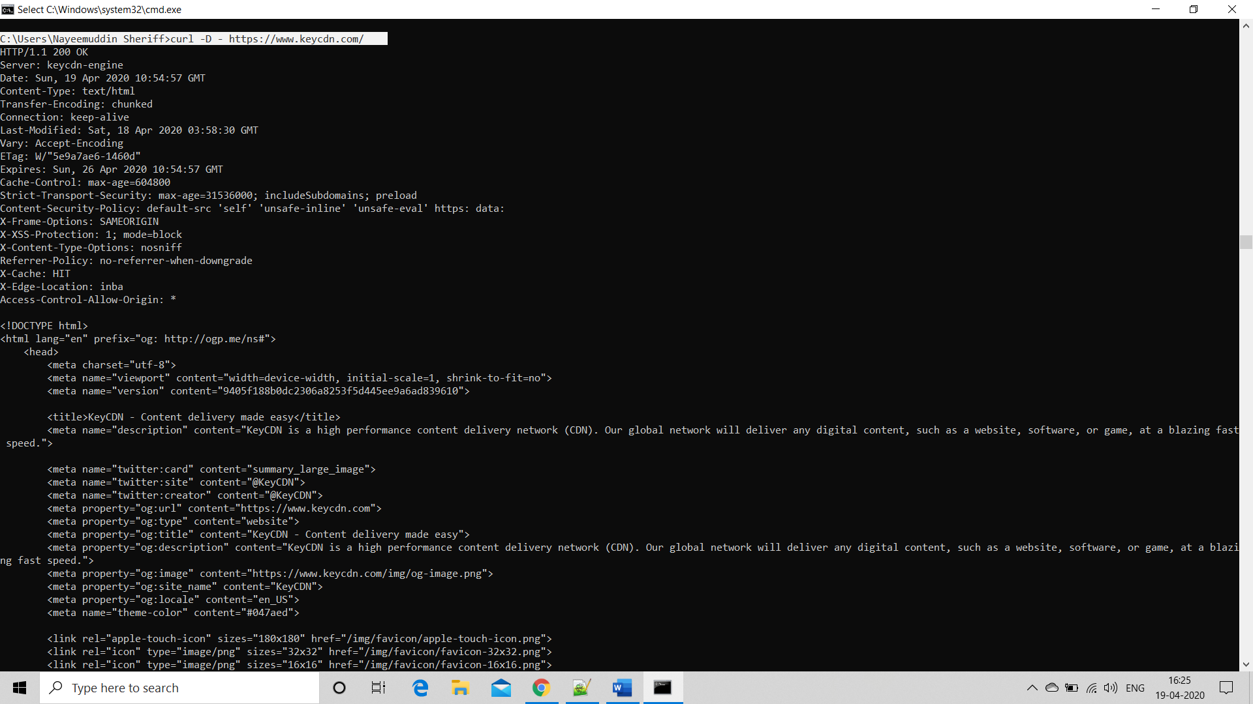

1. Testing the download time of an asset without any output

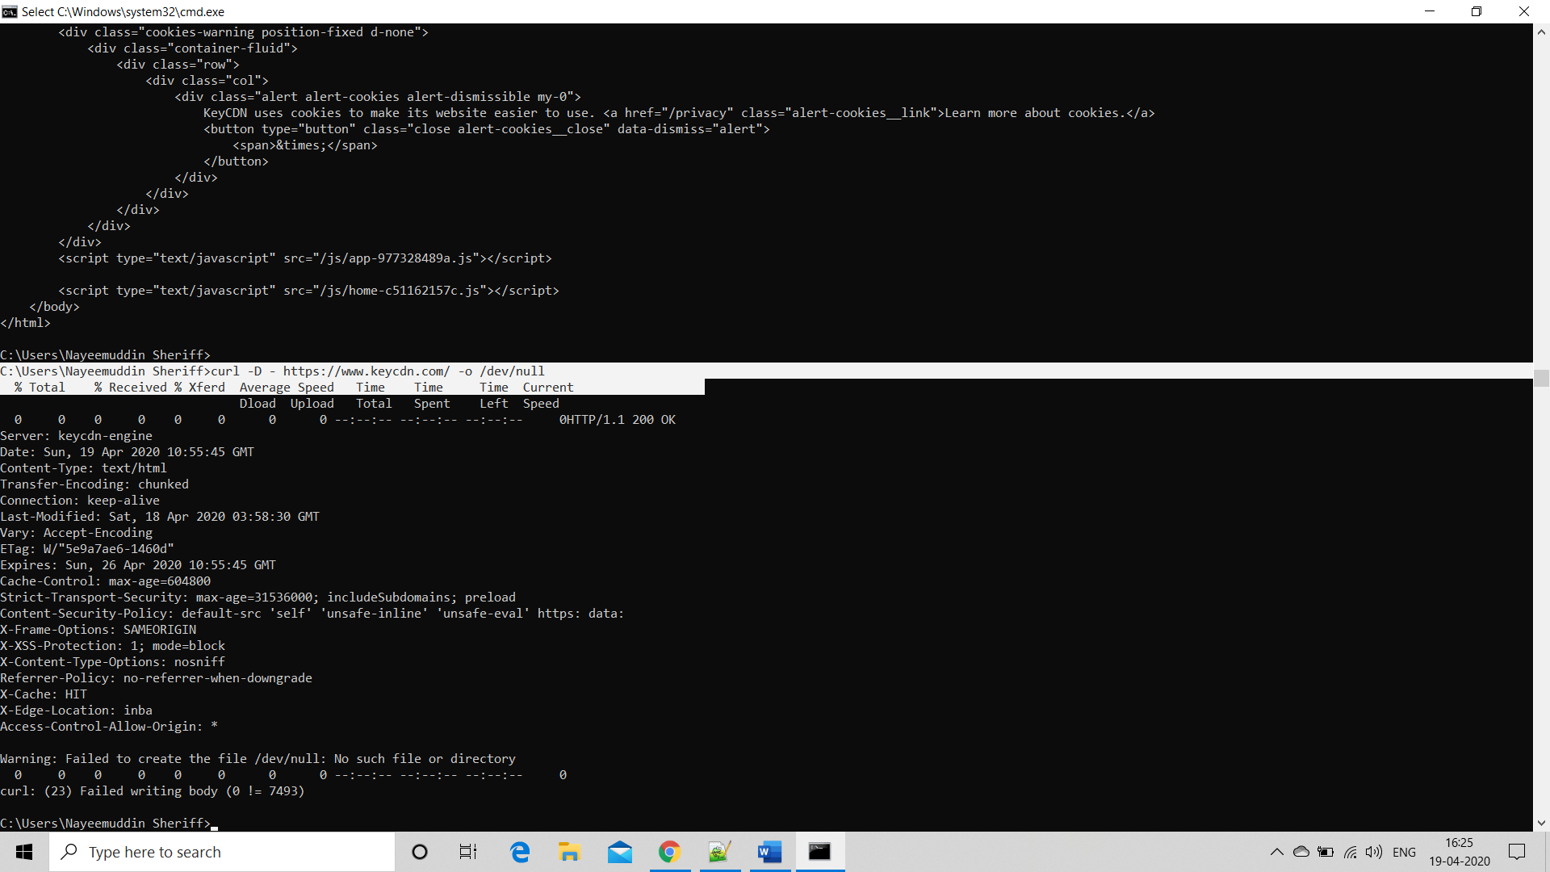

1. Specifying a maximum transfer rate

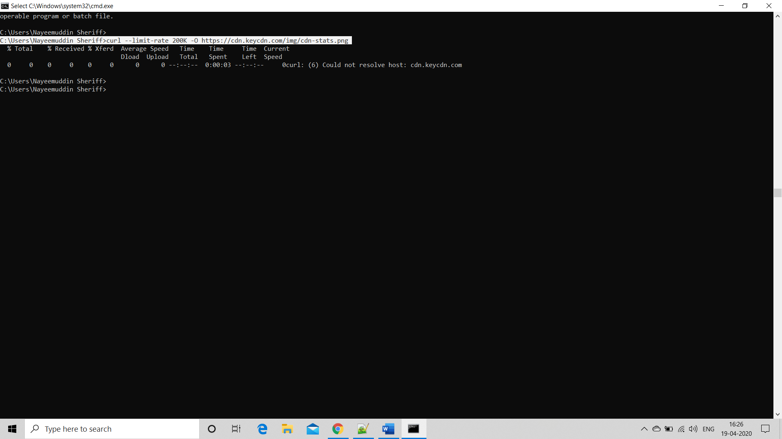

1. HTTP/2 support check

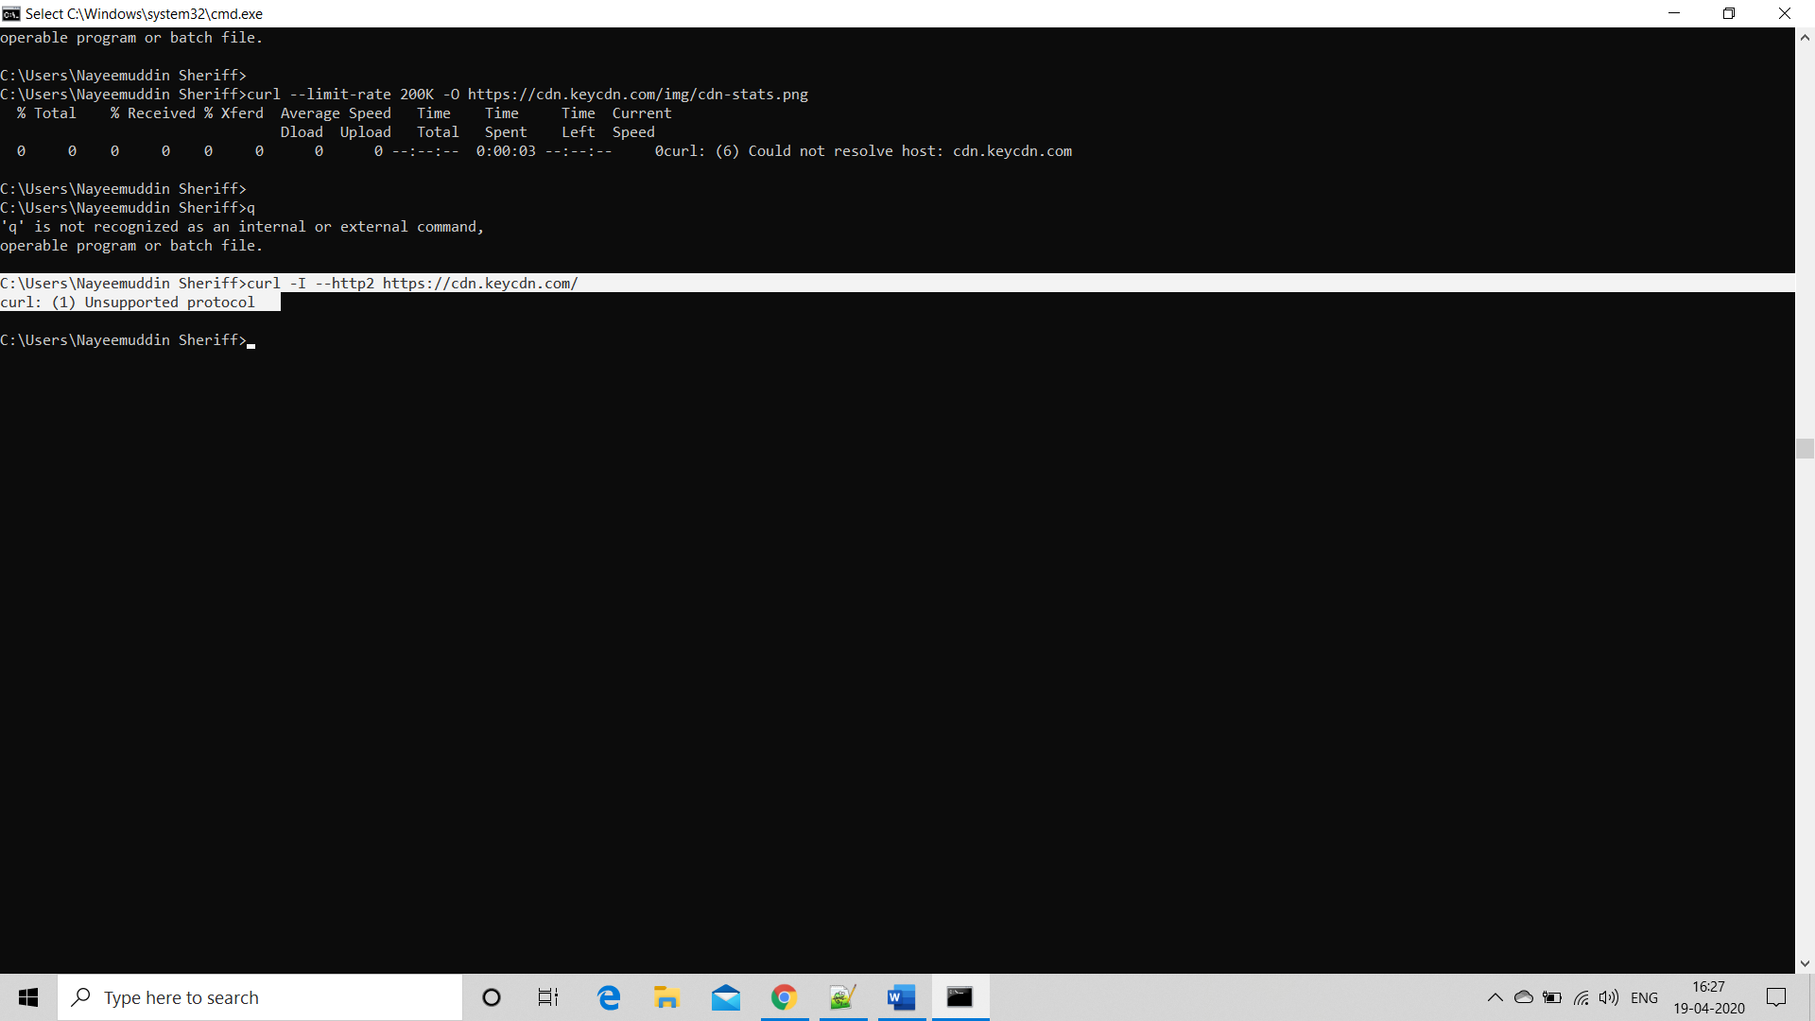

1. Retrieving a particular byte-range

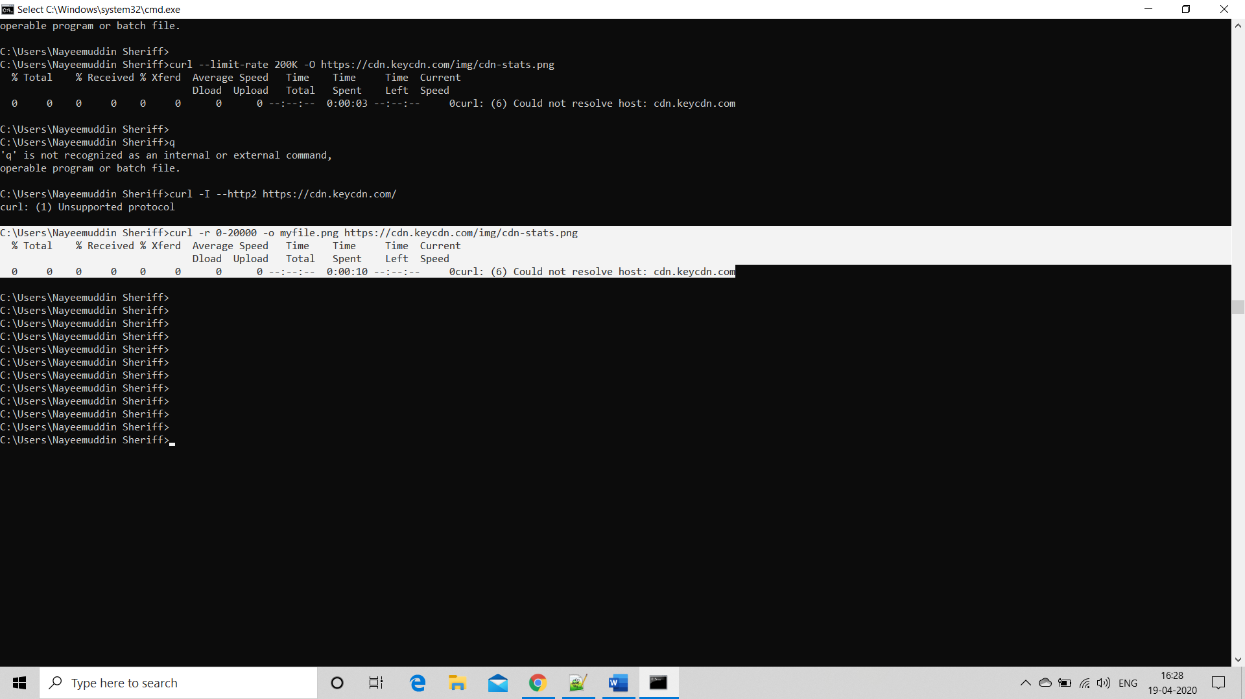

1. curl usage help

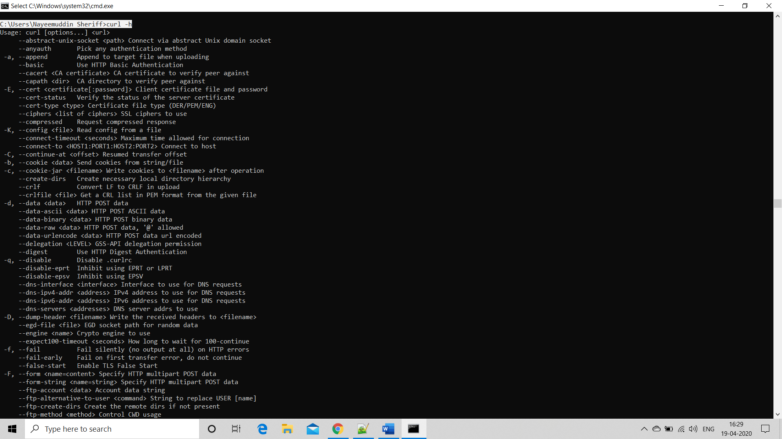

1. GET method

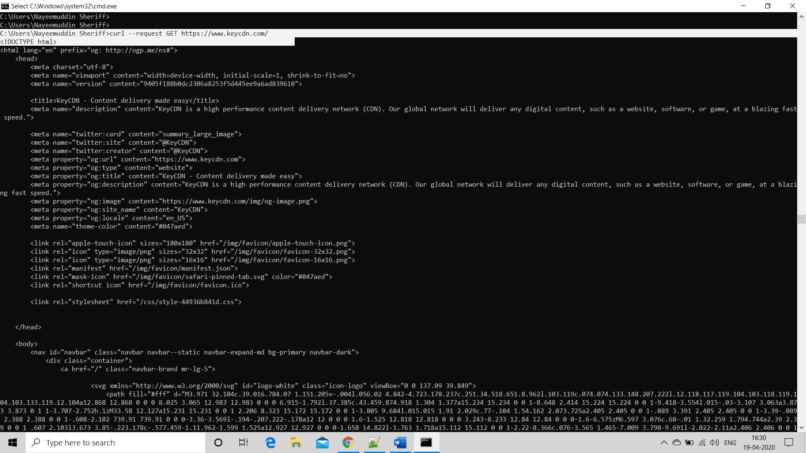

1. POST method

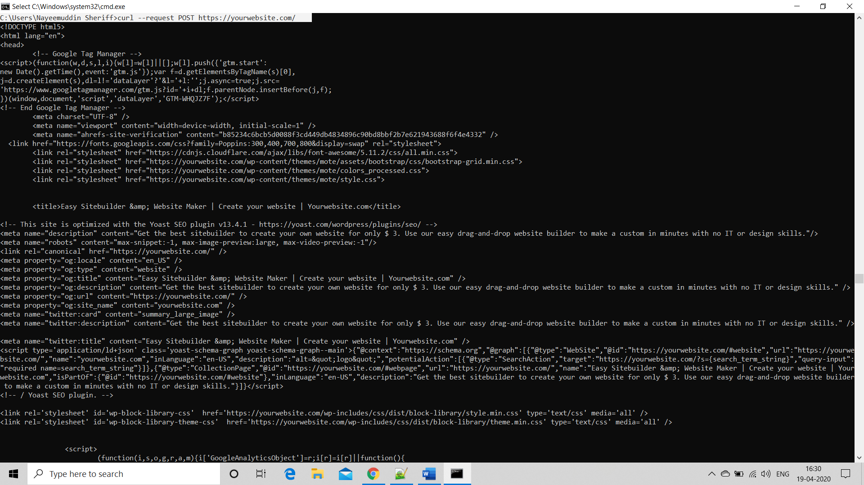

1. DELETE method

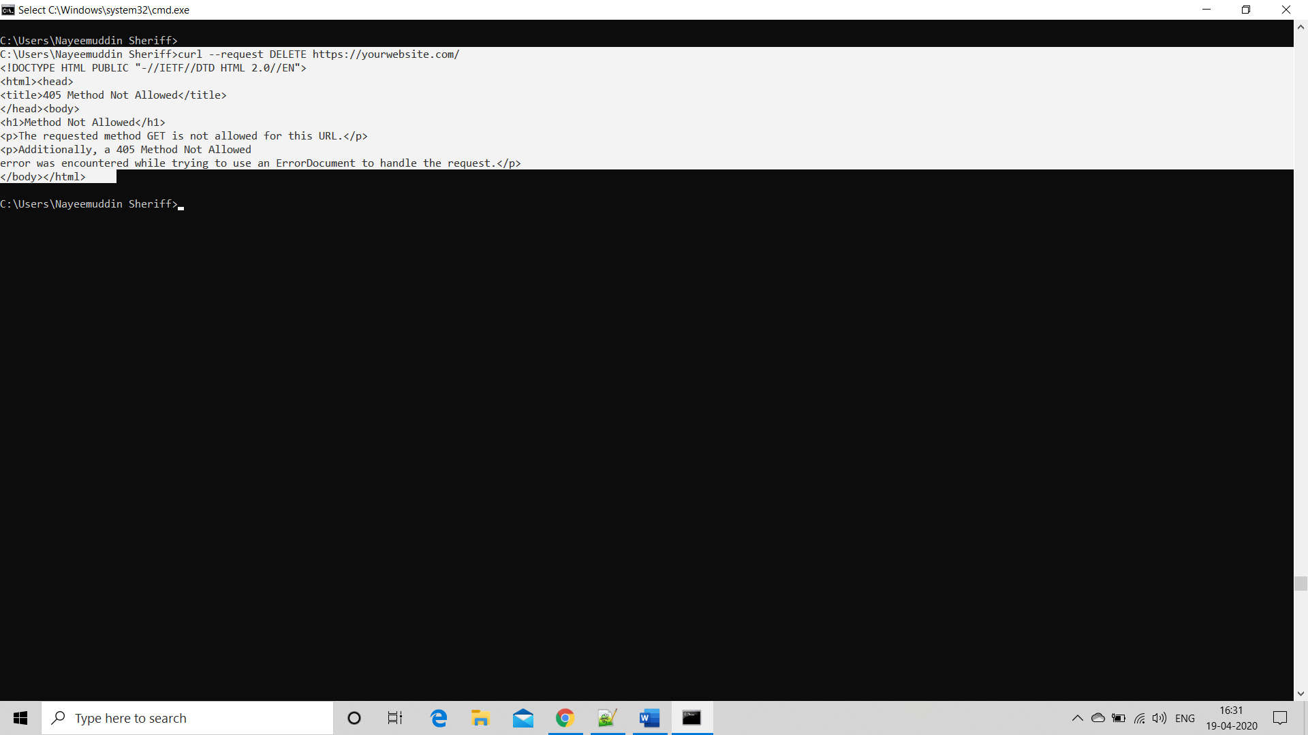

1. PUT method

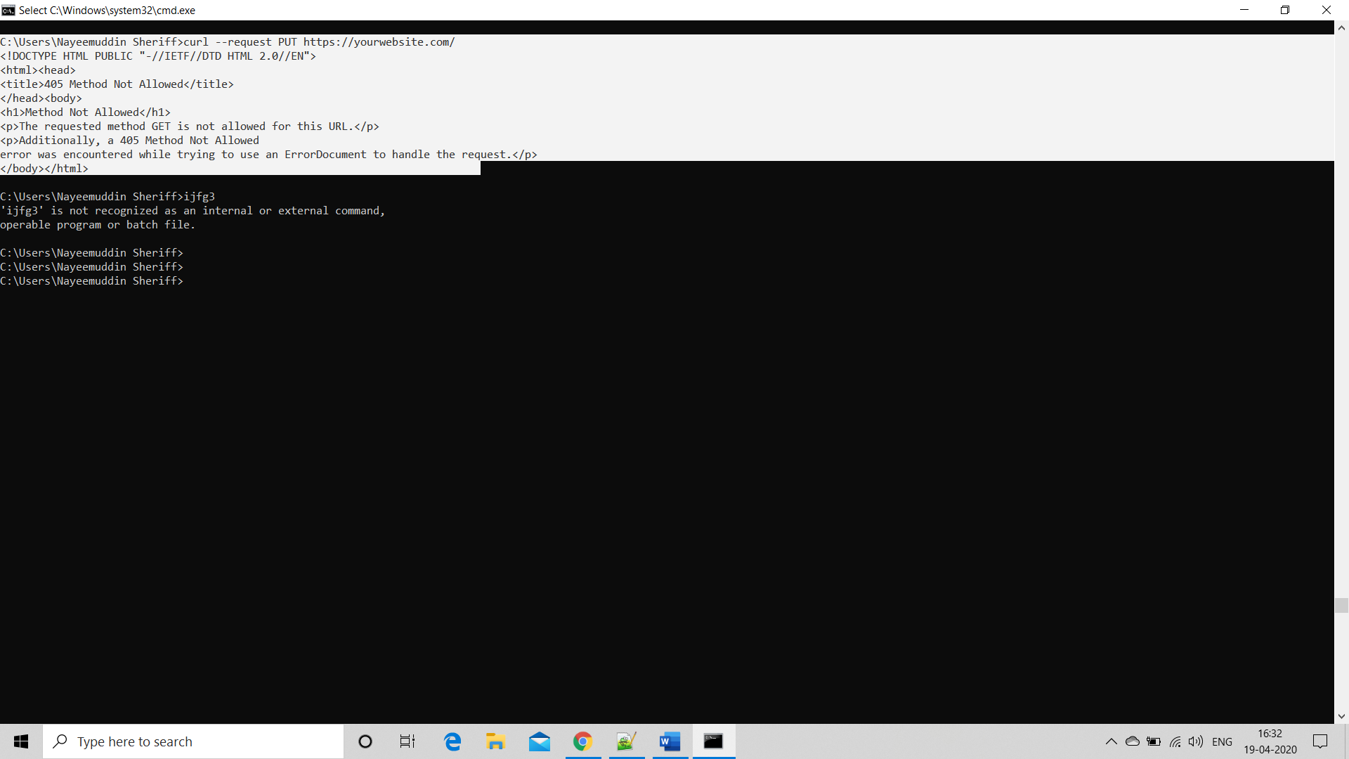

1. Making curl requests with data